**EMPLOYEE MANAGEMENT SYSTEM**

**Submitted by**

**GK SAI CHARAN (18E1606)**

**S NAVEETH (18E1653)**

**2020-2021**

**MINI PROJECT**

**IN**

**COMPUTER SCIENCE**



**DEPARTMENT OF COMPUTER SCIENCE**

**DG VAISHNAV COLLEGE**

**CHENNAI-600106**

**DWARAKA DOSS GOVERDHAN DOSS VAISHNAV COLLEGE (AUTONOMOUS)**

**ARUMBAKKAM, CHENNAI-600 106.**



**DEPARTMENT OF COMPUTER SCIENCE**

**SEMESTER VI: MINI PROJECT**

Certified that this is a record work done by …………………………..……. whose Register no. ………………………… of III B.Sc., Computer Science, during the academic year 2020 - 2021.

**Faculty In-charge Head In-charge**

Submitted for practical examination held on ………….…………… at Dwaraka Doss Goverdhan Doss Vaishnav College, Chennai-106.

**Internal Examiner External Examiner**

**TABLE OF CONTENTS**

|  |  |  |
| --- | --- | --- |
| **S.NO** | **CONTENTS** | **PAGE.NO** |
|  | **ACKNOWLEDGEMENT** |  |
| **1**  **2**  **3**  **4** | **ABSTRACT**  **INTRODUCTION**  **PROBLEM DEFINITION**  **SYSTEM CONFIGURATION**  **4.a HARDWARE CONFIGURATION**  **4.b SOFTWARE CONFIGURATION** |  |
| **5** | **ABOUT THE SOFTWARE**  **5.a PHP**  **5.b HTML**  **5.c CSS**  **5.d JAVASCRIPT**  **5.e MYSQL** |  |
| **6** | **SYSTEM DESIGN**  **6.a EXISTING SYSTEM**  **6.b PROPOSED SYSTEM** |  |
| **7** | **ABOUT THE PROJECT** |  |
| **8** | **SCREEN LAYOUTS** |  |
| **9** | **FUTURE ENHANCEMENTS** |  |
| **10** | **CONCLUSION** |  |
|  | **BIBILIOGRAPHY** |  |
|  |  |  |

**ACKNOWLEDGEMENT**

It is my pleasure to be indebted to various people, who directly or indirectly contributed in the development of this work and who influenced our thinking, behavior, and acts during the development of our project.

I express my sincere gratitude to Mrs. Aruna**,** worthy mentor, guide and a great teacher who influenced and inspired me in many ways.

Lastly, I would like to thank the almighty and my parents for their moral support and my friends with whom I shared our day-to-day experience and received lots of suggestions that improved our quality of work.

**ABSTRACT**

In this world of growing technologies everything has been computerized. With large number of work opportunities the Human workforce has increased. Thus there is a need of system which can handle the date of such a large number of Employees in an organization. This project simplifies the task of maintain records because of its user friendly nature.

The “EMPLOYEE MANAGEMENT SYSTEM” has been developed to override the problems prevailing in the practicing manual system. This software is supported to eliminate and in some cases reduce the hardships faced by this existing system. Moreover this system is designed for the particular need of the company to carry out operations in a smooth and effective manner.

The application is reduced as much as possible to avoid errors while entering the data. It also provides error message while entering invalid data. No formal knowledge is needed for the user to use this system. Thus by this all it proves it is user-friendly.

This project will allow admin to add new employees after proper authentication. Admin can also add new departments and posts. It can allocate employees to different departments at different posts. Database should store all personal details of employees such as full name, department, role etc. in different tables with proper relations.

This system enables the automation of work flow notifications and leave request. Work flow notification from administrator are stored in the backend and notified to employee, once employee log in to the system. Leave request made by the employee is placed for administrator approval, the administrator module checks up the leave availability and approves or rejects the request.

**INTRODUCTION**

Every organization, whether big or small, has human resource challenges to overcome, every organization has different employee management needs, and therefore we design exclusive employee management systems that are adapted to client managerial requirements. This is designed to assist in strategic planning, and will help client ensure that client organization is equipped with the right level of human resource for their future goals. Also, for those busy executive who are always on the go, our systems come with remote access features, which will allow client to manage their workforce anytime, at all times. These systems will ultimately allow client to better manage resources. One of main features in employee management system is assigning task and leave management which saves both time and money for the organization.

**PROBLEM DEFINITION**

1. Creating a login page.
2. Creating admin and employee panel.
3. Creating Database to manage details.
4. Creating new user registration, Leave management module for admin.
5. Creating view task and apply leave module for employee.

**SYSTEM CONFIGURATION**

**HARDWARE REQUIREMENTS**

* Ram : 2GB and Above
* Hard Disk : 500GB
* Processor : Intel Core
* Monitor : LCD

**SOFTWARE REQUIREMENTS**

* Front End : HTML, CSS and JavaScript
* Back End : PHP
* Server : WAMPP/XAMPP
* Database connectivity : MYSQL
* Operating System : Windows 7 or above
* Tool : Notepad/PHPSTORM
* Browser : Chrome/Firefox/Internet Explorer

**ABOUT THE SOFTWARE**

1. **PHP**

PHP is known as “**PHP: Hypertext Pre-processor**”. It is a server-side scripting language usually written in an HTML context. Unlike an ordinary HTML page, a PHP script is not sent directly to a client by the server; instead, it is parsed by the PHP binary or module, which is server-side installed. HTML elements in the script are left alone, but PHP code is interpreted and executed. PHP code in a script can query databases, create images, read and write files, talk to remote servers – the possibilities is endless. The output from PHP code is combined with the HTML in the script and the result sent to the user’s web-browser, therefore it can never tell the user whether the web-server uses PHP or not, because the entire browser sees is HTML.

PHP’s support for Apache and MySQL further increases its popularity. Apache is now the most-used web-server in the world, and PHP can be compiled as an Apache module. MySQL is a powerful free SQL database, and PHP provides a comprehensive set of functions for working with it. The combination of Apache, MySQL and PHP is all but unbeatable.

1. **HTML**

**HTML** or **Hyper Text Markup Language** is the standard markup language used to create web pages. HTML was created in 1991 by Tim Berners-Lee at CERN in Switzerland. It was designed to allow scientists to display and share their research.

HTML is written in the form of HTML elements consisting of *tags* enclosed in angle brackets (like <html>). HTML tags most commonly come in pairs like <h1> and </h1>, although some tags represent *empty elements* and so are unpaired, for example <img>. The first tag in a pair is the *start tag*, and the second tag is the *end tag* (they are also called *opening tags* and *closing tags*).

The purpose of a web browser is to read HTML documents and compose them into visible or audible web pages. The browser does not display the HTML tags, but uses the tags to interpret the content of the page. HTML describes the structure of a website semantically along with cues for presentation, making it a markup language rather than a programming language.

1. **CSS**

**Cascading Style Sheets** (**CSS**) is a style sheet language used for describing the look and formatting of a document written in a markup language. While most often used to style web pages and user interfaces written in HTML and XHTML, the language can be applied to any kind of XML document, including plain XML, SVG and XUL. CSS is a cornerstone specification of the web and almost all web pages use CSS style sheets to describe their presentation.

1. **JAVASCRIPT**

**JavaScript** (**JS**) is a dynamic computer programming language. It is most commonly used as part of web browsers, whose implementations allow client-side scripts to interact with the user, control the browser, communicate asynchronously, and alter the document content that is displayed. It is also being used in server-side network programming (with Node.js), game development and the creation of desktop and mobile applications.

JavaScript is a prototype-based scripting language with dynamic typing and has first-class functions. Its syntax was influenced by C. JavaScript copies many names and naming conventions from Java, but the two languages are otherwise unrelated and have very different semantics. The key design principles within JavaScript are taken from the self and Scheme programming languages. It is a multi-paradigm language, supporting object-oriented, imperative, and functional programming styles.

1. **MYSQL**

The database has become an integral part of almost every human's life. . A database that is implemented and interfaced on a computer is often termed a database server. One of the fastest SQL (Structured Query Language) database servers currently on the market is the MySQL server, developed by T.c.X. DataKonsultAB. MySQL, available for download at www.mysql.com, offers the database programmer with an array of options and capabilities rarely seen in other database servers. MySQL is free of charge for those wishing to use it for private and commercial use. Those wishing to develop applications specifically using MySQL should consult MySQL's licensing section, as there is charge for licensing the server.

**SYSTEM DESIGN**

**EXISTING SYSTEM**

* Its manual process for earlier system.
* Its more time consume for all process.
* Need for more resources.
* There is chance to lose record details.

**PROPOSED SYSTEM**

* Helps in maintaining the computerized employee details.
* Easy task assignment to employees
* Easy calculation of various leave in categories.
* Create new users to the system accordingly.

**ABOUT THE PROJECT**

The goal of Employee Management System is help to attracting, developing, and retaining employees and also by managing them effectively. It aims to achieve a fit between managing the organization’s employees and the overall strategic direction of the organization. EMS planning deals with recognizing and fulfilling the employee needs of an organization. In order to meet the effectiveness objective of management control, the Admin/HR plan should be formulated in such a way that it conforms to the organizational strategies and corporate plans. At the micro level, the organization needs to do career planning for employees and succession planning for key positions in the organization. At a macro level, the organization needs to carry out workforce (manpower) planning and salary planning. [***Employee Management System***](https://codeshoppy.com/shop/product/employee-management-system/)The nature of the HR planning process is primarily dependent upon the organizational size and the hierarchical structure within the organization.

**System Modules:**

**ADMIN**

* Login
* Create Employee details
* Leave approval
* Task Assign

**EMPLOYEE**

* Login
* View Task and Update Task
* Apply Leave and View Status

**MODULES:**

1. **Login Module**

The main activities in the application are the user login page for user. The other modules are followed by this login page. This module records only user and password of the user.

1. **Leave Approval**

Employee post leaves approval for admin.

1. **Create Employee Detail**

Admin can only generate ID and Password for all employees

1. **Task Assign**

Admin enter the task for employee through this system.

1. **Task view and updated**

Employee can view and updated the task details.

1. **Leave apply and view status**

Employee post the leave apply for admin. And can also view the status

**SOURCE CODE**

**LOGIN PAGE:**

<?php session_start();?>

<html>

<head>

<title>Login</title>

<link rel="stylesheet" href="css/style.css">

<script src="https://ajax.googleapis.com/ajax/libs/jquery/2.1.1/jquery.min.js"></script>

<script>

function formvalidation(){

var email=$('#inputEmail').val();

var password=$('#inputPassword').val();

var passlength=$('#inputPassword').val().length;

if(email=='')

{

alert("Please Enter your email");

return false;

}

if(password=='')

{

alert("Please Enter your password");

return false;

}

if(passlength<=4)

{

alert("Please Enter minimum 5 digit password");

return false;

}

}

</script>

</head>

<body>

<header>

<nav class="navbar navbar-default">

<div class="container-fluid">

<div class="navbar-header">

<button type="button" class="navbar-toggle collapsed" data-toggle="collapse" data-target="#bs-example-navbar-collapse-1">

<span class="sr-only">Toggle navigation</span>

<span class="icon-bar"></span>

<span class="icon-bar"></span>

<span class="icon-bar"></span>

</button>

<a class="navbar-brand" href="#">EMS</a>

</div> <div class="collapse navbar-collapse" id="bs-example-navbar-collapse-1">

<ul class="nav navbar-nav navbar-right">

<li><a href="login.php">Login</a></li>

</ul>

</div>

</div>

</nav>

</header>

<div class="container">

<div class="col-xs-6 col-xs-push-3 well">

<!------ register form start from here ---------------------->

<form class="form-horizontal" method="post" action="login-account.php" onSubmit="return formvalidation();">

<fieldset>

<legend>Lgoin</legend>

<?php

if(isset($_SESSION['error']))

{

echo $_SESSION['error'];

unset($_SESSION['error']);

}

if(isset($_SESSION['success']))

{

echo $_SESSION['success'];

unset($_SESSION['success']);

}

?>

<div class="form-group">

<label for="inputEmail" class="col-lg-2 control-label">Email</label>

<div class="col-lg-10">

<input type="email" class="form-control" name="email" id="inputEmail" placeholder="Email">

</div>

</div>

<div class="form-group">

<label for="inputPassword" class="col-lg-2 control-label">Password</label>

<div class="col-lg-10">

<input type="password" class="form-control" name="password" id="inputPassword" placeholder="Password">

</div>

</div>

<div class="form-group">

<div class="col-lg-10 col-lg-offset-2">

<button type="submit" class="btn btn-primary">Login</button>

</div>

</div>

</fieldset>

</form>

<!------------------------register form end here----------------->

</div>

</div>

</body>

</html>

**ADMIN:-**

**ADMIN DASHBOARD: -**

<?php include "../auth/auth.php";?>

<?php include "authentication.php";?>

<html>

<head>

<title>Dashboard</title>

<link rel="stylesheet" href="../css/style.css">

<script src="https://ajax.googleapis.com/ajax/libs/jquery/2.1.1/jquery.min.js"></script>

</head>

<body>

<!------including header here --------->

<?php include "header.php";?>

<!------end header here --------->

<div class="container">

<?php echo "Welcome to admin Dashboard";?>

<h1>User Records</h1>

<table class="table table-striped table-hover ">

<thead>

<tr>

<th>Sr No.</th>

<th>Name</th>

<th>Email</th>

<th>Department</th>

<th>Role</th>

<th>Action</th>

</tr>

</thead>

<tbody>

<?php

$i=1;

$query="Select * from users";

$res=mysqli_query($conn, $query);

$count=mysqli_num_rows($res);

if($count>0)

{

while($row=mysqli_fetch_array($res))

{

?>

<tr>

<td><?php echo $i; ?></td>

<td><?php echo $row['name'];?></td>

<td><?php echo $row['email'];?></td>

<td><?php echo $row['department'];?></td>

<td><?php echo $row['role'];?></td>

<td><a href="edit-user.php?id=<?php echo $row['user_id'];?>">Edit</a> | <a href="delete-user.php?id=<?php echo $row['user_id'];?>">Delete</a></td>

</tr>

<?php $i++;}}else{

echo "No record Found!";

} ?>

</tbody>

</table>

</div>

</body>

</html>

**ADD EMPLOYEES:-**

<?php include "../auth/auth.php";?>

<?php include "authentication.php";?>

<html>

<head>

<title>Register</title>

<link rel="stylesheet" href="../css/style.css">

<script src="https://ajax.googleapis.com/ajax/libs/jquery/2.1.1/jquery.min.js"></script>

<script>

function formvalidation(){

var name=$('#inputName').val();

var email=$('#inputEmail').val();

var password=$('#inputPassword').val();

var passlength=$('#inputPassword').val().length;

if(name=='')

{

alert("Please Enter your name");

return false;

}

if(email=='')

{

alert("Please Enter your email");

return false;

}

if(password=='')

{

alert("Please Enter your password");

return false;

}

if(passlength<=4)

{

alert("Please Enter minimum 5 digit password");

return false;

}

}

</script>

</head>

<body>

<!------including header here --------->

<?php include "header.php";?>

<!------end header here --------->

<div class="container">

<div class="col-xs-6 col-xs-push-3 well">

<!------ register form start from here ---------------------->

<form class="form-horizontal" method="post" action="insert-user.php" onSubmit="return formvalidation();">

<fieldset>

<legend>Register</legend>

<?php

if(isset($_SESSION['success']))

{

echo $_SESSION['success'];

unset($_SESSION['success']);

}

?>

<div class="form-group">

<label for="inputEmail" class="col-lg-2 control-label">Name</label>

<div class="col-lg-10">

<input type="text" class="form-control" name="inputName" id="inputName" placeholder="Name">

</div>

</div>

<div class="form-group">

<label for="inputEmail" class="col-lg-2 control-label">Email</label>

<div class="col-lg-10">

<input type="email" class="form-control" name="email" id="inputEmail" placeholder="Email">

</div>

</div>

<div class="form-group">

<label for="inputPassword" class="col-lg-2 control-label">Password</label>

<div class="col-lg-10">

<input type="password" class="form-control" name="password" id="inputPassword" placeholder="Password">

</div>

</div>

<div class="form-group">

<label class="col-lg-2 control-label">Department</label>

<div class="col-lg-10">

<div class="radio">

<label>

<input type="radio" name="depart" id="depart" value="Web Development" checked="">

Web Development

</label>

</div>

<div class="radio">

<label>

<input type="radio" name="depart" id="depart" value="SEO">

SEO

</label>

</div>

</div>

</div>

<div class="form-group">

<label class="col-lg-2 control-label">Role</label>

<div class="col-lg-10">

<div class="radio">

<label>

<input type="radio" name="role" id="role" value="admin" checked="">

Admin

</label>

</div>

<div class="radio">

<label>

<input type="radio" name="role" id="role" value="employee">

Employee

</label>

</div>

</div>

</div>

<div class="form-group">

<div class="col-lg-10 col-lg-offset-2">

<button type="reset" class="btn btn-default">Cancel</button>

<button type="submit" class="btn btn-primary">Submit</button>

</div>

</div>

</fieldset>

</form>

<!------------------------register form end here----------------->

</div>

</div>

</body>

</html>

**ASSIGN LEAVES:-**

<?php include "../auth/auth.php";?>

<?php include "authentication.php";?>

<html>

<head>

<title>Assign Employee Leave</title>

<link rel="stylesheet" href="../css/style.css">

<script src="https://ajax.googleapis.com/ajax/libs/jquery/2.1.1/jquery.min.js"></script>

</head>

<body>

<!------including header here --------->

<?php include "header.php";?>

<!------end header here --------->

<div class="container">

<div class="col-xs-10 col-xs-push-1 well">

<?php

if(isset($_SESSION['success']))

{

echo $_SESSION['success'];

unset($_SESSION['success']);

}

?>

<!------ register form start from here ---------------------->

<form class="form-horizontal" method="post" action="insert-leave.php" >

<fieldset>

<legend>Assign leave <a href="all-leave.php" class="btn btn-primary" style="margin:5px;">All Leave</a> <a href="all-applied-leave.php" class="btn btn-primary" style="margin:5px;">All Applied Leave</a></legend>

<!----left box----------->

<div class="col-xs-3" style="background-color:#d9d9d9;padding:15px;">

<div class="form-group">

<label class="col-lg-12"><b>Employee Lists</b></label>

<input type="hidden" name="assign_by" value="<?php echo $_SESSION['user_id']; ?>">

<div class="col-lg-12">

<?php

$query="Select * from users where `role`='employee' order by user_id DESC";

$res=mysqli_query($conn, $query);

$count=mysqli_num_rows($res);

while($row=mysqli_fetch_array($res))

{

?>

<div class="checkbox">

<label>

<input type="checkbox" name="emp[]" value="<?php echo $row['user_id'];?>" >

<?php echo $row['name'];?>

</label>

</div>

<?php } ?>

</div>

</div>

</div>

<!----right box----------->

<div class="col-xs-9">

<div class="form-group">

<label for="inputEmail" class="col-lg-3"><b>Valid From:</b></label>

<div class="col-lg-9">

<input type="date" name="validfrm" placeholder="dd/mm/yyyy" class="form-control">

</div>

</div>

<div class="form-group">

<label for="inputEmail" class="col-lg-3"><b>Valid To:</b></label>

<div class="col-lg-9">

<input type="date" name="validto" placeholder="dd/mm/yyyy" class="form-control">

</div>

</div>

<div class="form-group">

<label for="inputEmail" class="col-lg-3"><b>Earning Leave:</b></label>

<div class="col-lg-9">

<input type="text" name="eleave" placeholder="No. of leave" class="form-control">

</div>

</div>

<div class="form-group">

<label for="inputEmail" class="col-lg-3"><b>Medical Leave:</b></label>

<div class="col-lg-9">

<input type="text" name="mleave" placeholder="No. of leave" class="form-control">

</div>

</div>

<div class="form-group">

<label for="inputEmail" class="col-lg-3"><b>Casual Leave:</b></label>

<div class="col-lg-9">

<input type="text" name="cleave" placeholder="No. of leave" class="form-control">

</div>

</div>

</div>

<div class="form-group">

<div class="col-lg-12 col-lg-offset-3">

<button type="reset" class="btn btn-default">Cancel</button>

<button type="submit" class="btn btn-primary">Submit</button>

</div>

</div>

</fieldset>

</form>

<!------------------------register form end here----------------->

</div>

</div>

</body>

</html>

**APPROVE/REJECT LEAVE:-**

<?php include "../auth/auth.php";?>

<?php include "authentication.php";?>

<html>

<head>

<title>All Applied Leaves</title>

<link rel="stylesheet" href="../css/style.css">

<script src="https://ajax.googleapis.com/ajax/libs/jquery/2.1.1/jquery.min.js"></script>

</head>

<body>

<!------including header here --------->

<?php include "header.php";?>

<?php

if(isset($_POST['approved']))

{

$status="Approved";

$comment=$_POST['comment'];

$id=$_POST['id'];

$query="UPDATE `applied_leave` set `status`='$status', `comment`='$comment' where `id`='$id'";

$res=mysqli_query($conn,$query);

if($res){

$_SESSION['success']="Row Updated successfully!";

}else{

echo "Data not Updated, please try again!";

}

}

if(isset($_POST['rejected']))

{

$status= "Rejected";

$comment=$_POST['comment'];

$id=$_POST['id'];

$query="UPDATE `applied_leave` set `status`='$status', `comment`='$comment' where `id`='$id'";

$res=mysqli_query($conn,$query);

if($res){

$_SESSION['success']="Row Updated successfully!";

}else{

echo "Data not Updated, please try again!";

}

}

?>

<!------end header here --------->

<div class="container">

<h3>All Applied Leave Lists</h3>

<?php if(isset($_SESSION['success'])){

echo $_SESSION['success'];

unset($_SESSION['success']);

}

?>

<table class="table table-striped table-hover ">

<thead>

<tr>

<th>Sr No.</th>

<th>Employee Name</th>

<th>Earning Leave</th>

<th>Medical Leave</th>

<th>Casual Leave</th>

<th>From</th>

<th>To</th>

<th>Status</th>

<th>Comment</th>

<th>&nbsp;</th>

</tr>

</thead>

<tbody>

<?php

$i=1;

$query="Select * from `applied_leave` t1 join `users` t2 on t1.apply_by=t2.user_id";

$res=mysqli_query($conn, $query);

$count=mysqli_num_rows($res);

if($count>0)

{

while($row=mysqli_fetch_array($res))

{

?>

<tr>

<td><?php echo $i; ?></td>

<td><?php echo $row['name']; ?></td>

<td><?php echo $row['e_leave'];?></td>

<td><?php echo $row['m_leave'];?></td>

<td><?php echo $row['c_leave'];?> </td>

<td><?php echo $row['l_from'];?></td>

<td><?php echo $row['l_to'];?></td>

<td style="color:green;"><?php echo $row['status'];?></td>

<td><form method="post" action="" >

<textarea name="comment"></textarea></td>

<input type="hidden" name="id" value="<?php echo $row['id'];?>">

<td>

<button type="submit" name="approved" class="btn btn-primary">Approved</button>

<button type="submit" name="rejected" class="btn btn-primary">X</button>

</form></td>

</tr>

<?php $i++;}}else{

echo "No record Found!";

} ?>

</tbody>

</table>

</div>

</body>

</html>

**ASSIGN TASK:-**

<?php include "../auth/auth.php";?>

<?php include "authentication.php";?>

<html>

<head>

<title>Task</title>

<link rel="stylesheet" href="../css/style.css">

<script src="https://ajax.googleapis.com/ajax/libs/jquery/2.1.1/jquery.min.js"></script>

</head>

<body>

<!------including header here --------->

<?php include "header.php";?>

<!------end header here --------->

<div class="container">

<div class="col-xs-10 col-xs-push-1 well">

<?php

if(isset($_SESSION['success']))

{

echo $_SESSION['success'];

unset($_SESSION['success']);

}

?>

<!------ register form start from here ---------------------->

<form class="form-horizontal" method="post" action="insert-task.php" onSubmit="return formvalidation();">

<fieldset>

<legend>Assign Task <a href="all-task.php" class="btn btn-primary" style="margin:5px;">All Task</a></legend>

<!----left box----------->

<div class="col-xs-3" style="background-color:#d9d9d9;padding:15px;">

<div class="form-group">

<label class="col-lg-12"><b>Employee Lists</b></label>

<input type="hidden" name="assign_by" value="<?php echo $_SESSION['user_id']; ?>">

<div class="col-lg-12">

<?php

$query="Select * from users where `role`='employee' order by user_id DESC";

$res=mysqli_query($conn, $query);

$count=mysqli_num_rows($res);

while($row=mysqli_fetch_array($res))

{

?>

<div class="checkbox">

<label>

<input type="checkbox" name="emp[]" value="<?php echo $row['user_id'];?>" >

<?php echo $row['name'];?>

</label>

</div>

<?php } ?>

</div>

</div>

</div>

<!----right box----------->

<div class="col-xs-9">

<div class="form-group">

<label for="inputEmail" class="col-lg-12"><b>Message</b></label>

<div class="col-lg-12">

<textarea class="form-control" rows="10" name="message" placeholder="Message/ Task" style="background-color:#d9d9d9;padding:5px;"></textarea>

</div>

</div>

</div>

<div class="form-group">

<div class="col-lg-12 col-lg-offset-3">

<button type="reset" class="btn btn-default">Cancel</button>

<button type="submit" class="btn btn-primary">Submit</button>

</div>

</div>

</fieldset>

</form>

<!------------------------register form end here----------------->

</div>

</div>

</body>

</html>

**EMPLOYEE:**

**VIEW TASK:**

<?php include "../auth/auth.php";?>

<?php include "authentication.php";?>

<html>

<head>

<title>Task</title>

<link rel="stylesheet" href="../css/style.css">

<script src="https://ajax.googleapis.com/ajax/libs/jquery/2.1.1/jquery.min.js"></script>

</head>

<body>

<!------including header here --------->

<?php include "header.php";?>

<!------end header here --------->

<div class="container">

<h3>All Task Lists</h3>

<table class="table table-striped table-hover ">

<thead>

<tr>

<th>Sr No.</th>

<th>Task</th>

<th>Date</th>

<th>Action</th>

</tr>

</thead>

<tbody>

<?php

$i=1;

$query="Select * from task where `user_id`='".$_SESSION['user_id']."'";

$res=mysqli_query($conn, $query);

$count=mysqli_num_rows($res);

if($count>0)

{

while($row=mysqli_fetch_array($res))

{

?>

<tr>

<td><?php echo $i; ?></td>

<td><a href="view-message.php?id=<?php echo $row['t_id'];?>"><?php echo substr($row['task'],0,50);?></a></td>

<td><?php echo $row['date_time'];?></td>

<td><a href="view-message.php?id=<?php echo $row['t_id'];?>">view</a> </td>

</tr>

<?php $i++;}}else{

echo "No record Found!";

} ?>

</tbody>

</table>

</div>

</body>

</html>

**APPLY LEAVE:**

<?php include "../auth/auth.php";?>

<?php include "authentication.php";?>

<html>

<head>

<title>Leave</title>

<link rel="stylesheet" href="../css/style.css">

<script src="https://ajax.googleapis.com/ajax/libs/jquery/2.1.1/jquery.min.js"></script>

</head>

<body>

<!------including header here --------->

<?php include "header.php";?>

<!------end header here --------->

<div class="container">

<h3>Leave Lists <a href="applied-leave.php" class="btn btn-primary" style="margin:5px;">All Applied Leave</a></h3>

<table class="table table-striped table-hover ">

<thead>

<tr> <th>Name</th>

<th>Earning Leave</th>

<th>Medical Leave</th>

<th>Casual Leave</th>

<th>Valid From</th>

<th>Valid To</th>

</tr>

</thead>

<tbody>

<?php

$i=1;

$user_id=$_SESSION['user_id'];

$query="Select * from `assign_leave` t1 join `users` t2 on t1.assign_to=t2.user_id where t2.user_id=$user_id";

$res=mysqli_query($conn, $query);

$count=mysqli_num_rows($res);

if($count>0)

{

while($row=mysqli_fetch_array($res))

{

?>

<tr>

<td ><?php echo $row['name'];?></td>

<td class="eleave"><?php echo $row['e_leave'];?></td>

<td class="mleave"><?php echo $row['m_leave'];?></td>

<td class="cleave"><?php echo $row['c_leave'];?> </td>

<td class="v_from"><?php echo $row['v_from'];?></td>

<td class="v_to"><?php echo $row['v_to'];?></td>

</tr>

<?php $i++;}}else{

echo "No record Found!";

} ?>

</tbody>

</table>

<div class="col-xs-6 col-xs-push-3 well">

<form class="form-horizontal" method="post" action="apply-leave.php" >

<input type="hidden" name="user_id" value="<?php echo $_SESSION['user_id'];?>">

<fieldset>

<legend>Apply Leave </legend>

<p><?php if(isset($_SESSION['success'])){

echo $_SESSION['success'];

unset($_SESSION['success']);

} ?></p>

<!----left box----------->

<!----right box----------->

<div class="col-xs-9">

<div class="form-group">

<label for="inputEmail" class="col-lg-3"><b>Leave From:</b></label>

<div class="col-lg-9">

<input type="date" name="l_from" placeholder="dd/mm/yyyy" class="form-control" onBlur="checkDate(this.value)">

</div>

</div>

<div class="form-group">

<label for="inputEmail" class="col-lg-3"><b>Leave To:</b></label>

<div class="col-lg-9">

<input type="date" name="l_to" placeholder="dd/mm/yyyy" class="form-control" onBlur="checkDate(this.value)">

</div>

</div>

<div class="form-group">

<label for="inputEmail" class="col-lg-3"><b>Earning Leave:</b></label>

<div class="col-lg-9">

<input type="text" name="eleave" placeholder="No. of leave" class="form-control" onBlur="checkeleavequan(this.value)">

</div>

</div>

<div class="form-group">

<label for="inputEmail" class="col-lg-3"><b>Medical Leave:</b></label>

<div class="col-lg-9">

<input type="text" name="mleave" placeholder="No. of leave" class="form-control" onBlur="checkmleavequan(this.value)">

</div>

</div>

<div class="form-group">

<label for="inputEmail" class="col-lg-3"><b>Casual Leave:</b></label>

<div class="col-lg-9">

<input type="text" name="cleave" placeholder="No. of leave" class="form-control" onBlur="checkcleavequan(this.value)">

</div>

</div>

</div>

<div class="form-group">

<div class="col-lg-12">

<button type="reset" class="btn btn-default">Cancel</button>

<button type="submit" class="btn btn-primary">Submit</button>

</div>

</div>

</fieldset>

</form>

</div>

</div>

<script>

function checkDate(str){

var vfrm=$('.v_from').text();

var vto=$('.v_to').text();

var lfrm=str;

var date1 = new Date(vfrm);

var date2 = new Date(lfrm);

var diffDays = parseInt((date2 - date1) / (1000 * 60 * 60 * 24));

var date3 = new Date(lfrm);

var date4 = new Date(vto);

var diffDays2 = parseInt((date4 - date3) / (1000 * 60 * 60 * 24));

if(diffDays>=0 && diffDays2>=0){

return true;

}else{

//alert('Please enter valid date');

}

}

function checkeleavequan(str){

var vfrm=$('.eleave').text();

var lqty=str;

if(vfrm>=lqty)

{

return true;

}else{

//alert('Please enter valid Earning leave quantity');

}

}

function checkmleavequan(str){

var vfrm=$('.mleave').text();

var lqty=str;

if(vfrm>=lqty)

{

return true;

}else{

//alert('Please enter valid Medical leave quantity');

return false;

}

}

function checkcleavequan(str){

var vfrm=$('.cleave').text();

var lqty=str;

if(vfrm>=lqty)

{

return true;

}else{

//alert('Please enter valid Casual leave quantity');

return false;

}

}

</script>

</body>

</html>

**SCREEN LAYOUTS**

**LOGIN PAGE**

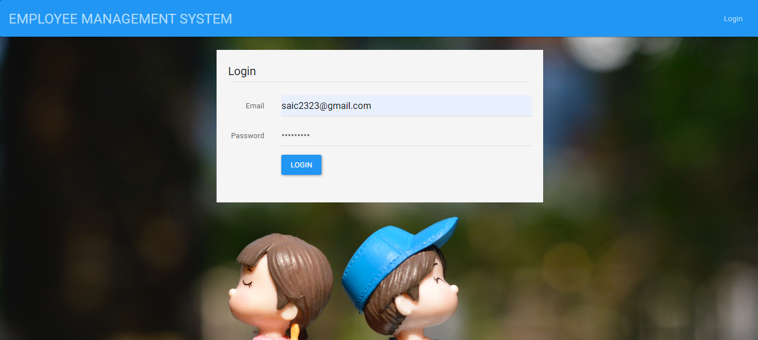

**ADMIN PANEL**

**DASHBOARD**

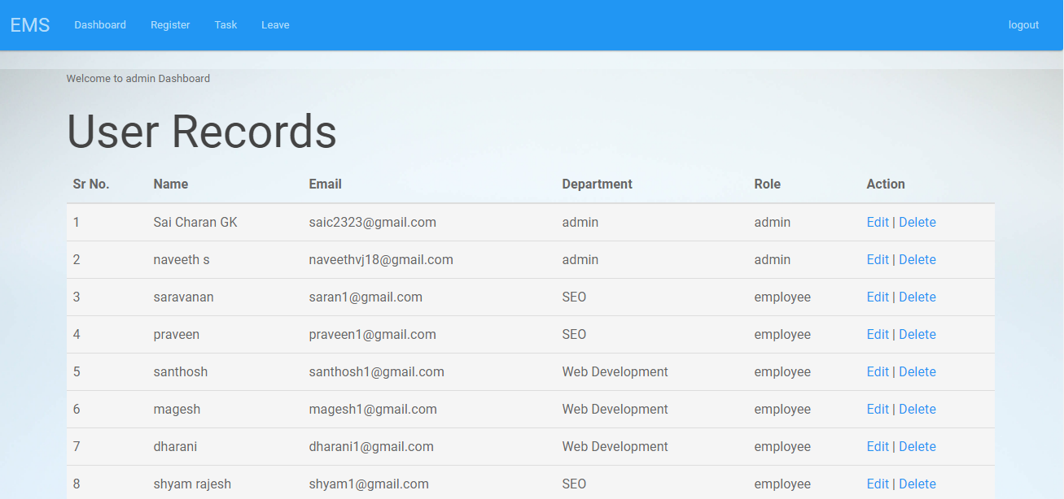

**REGISTER, EDIT USER, ASSIGN TASK**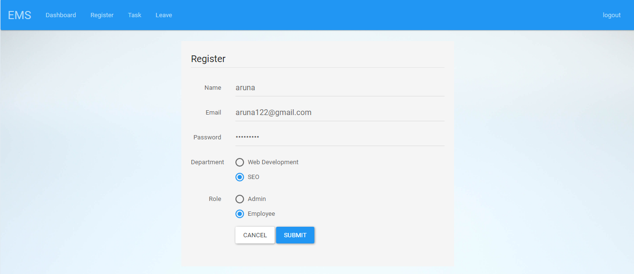

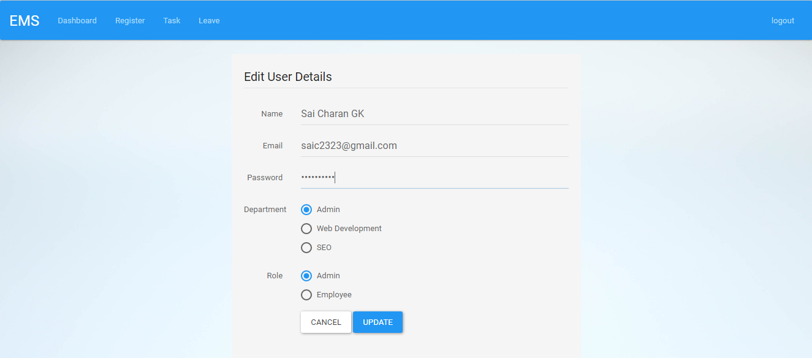

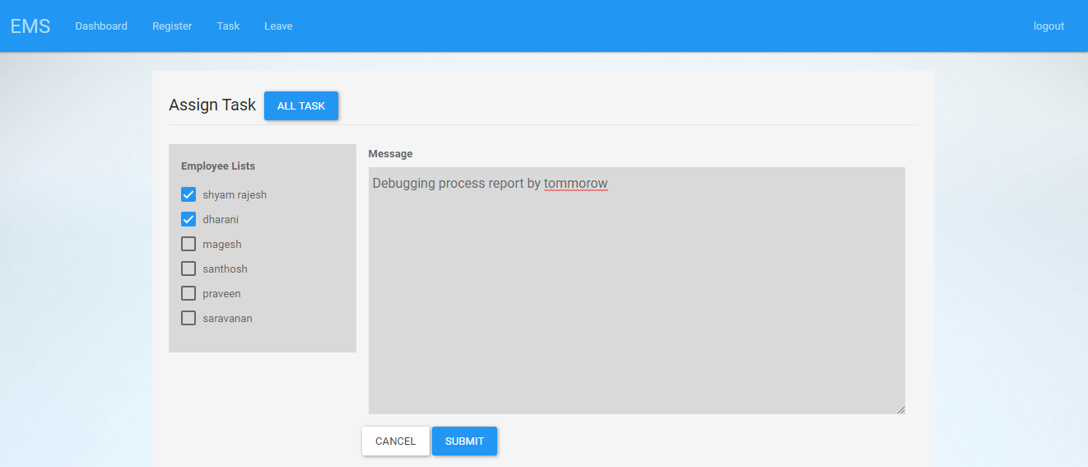

**ALL TASK, REPLY TASK, ASSIGN LEAVE**

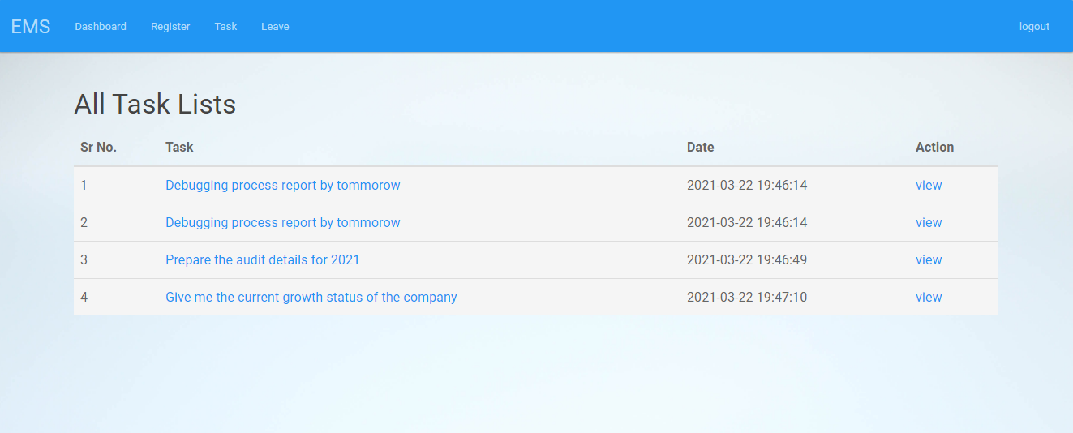

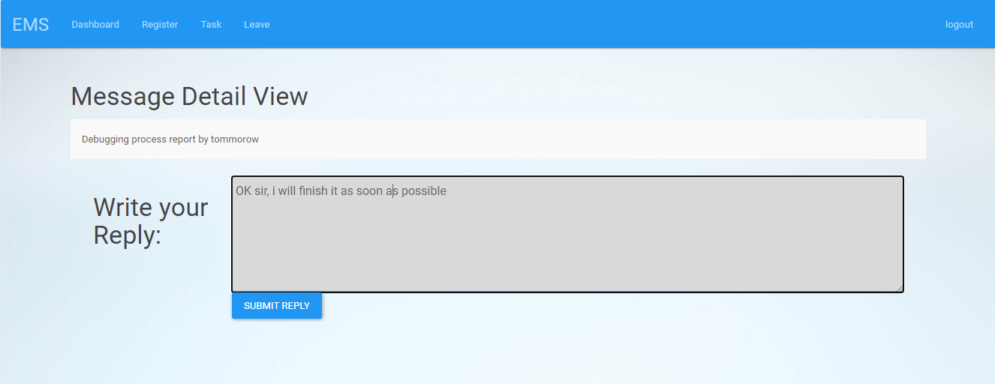

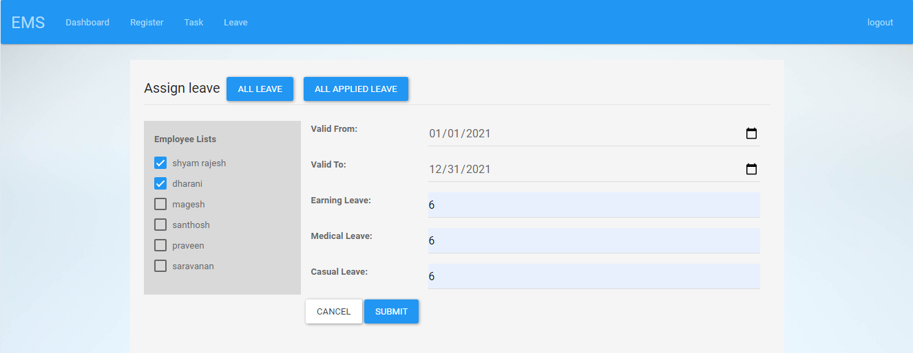

**ALL LEAVE, APPROVE/REJECT LEAVE**

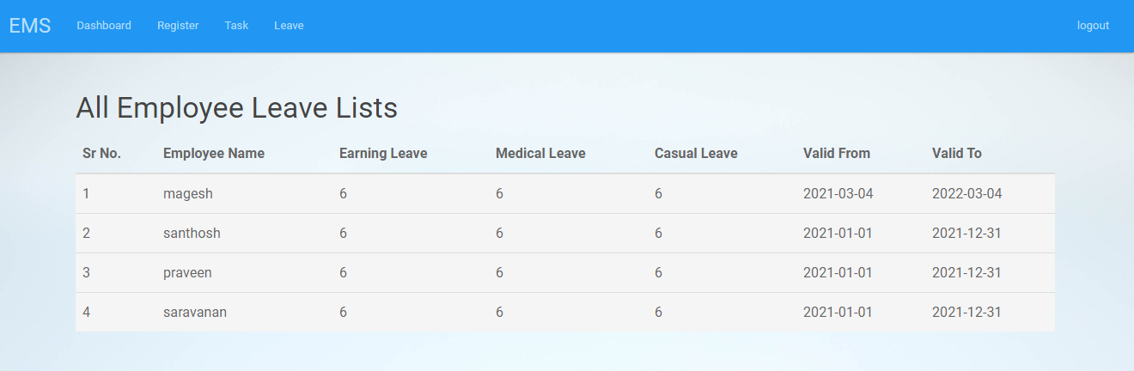

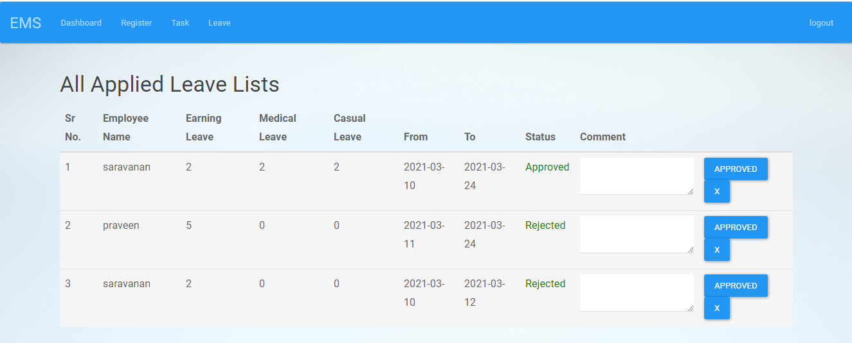

**EMPLOYEE PANEL**

**DASHBOARD, VIEW TASK, REPLY TASK**

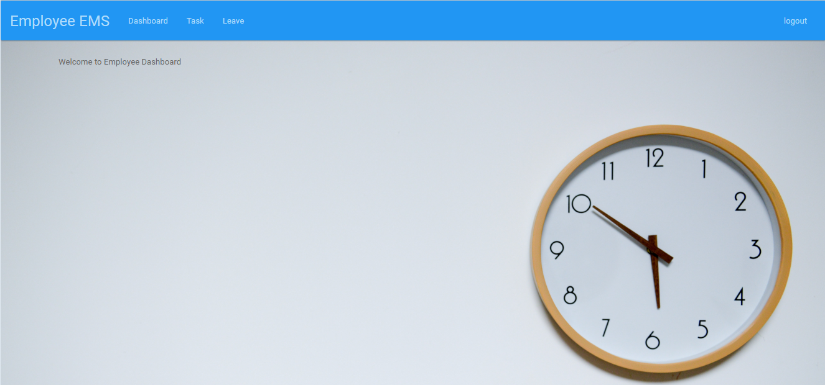

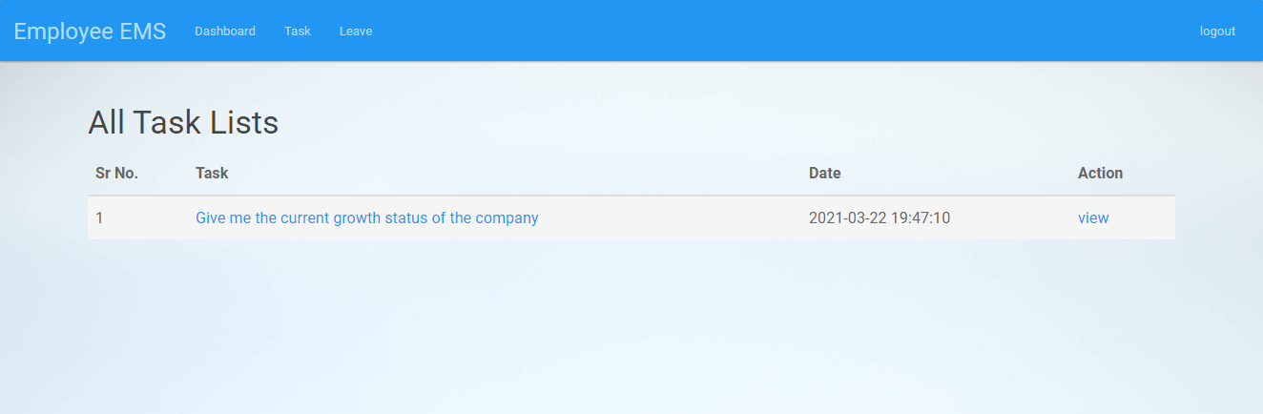

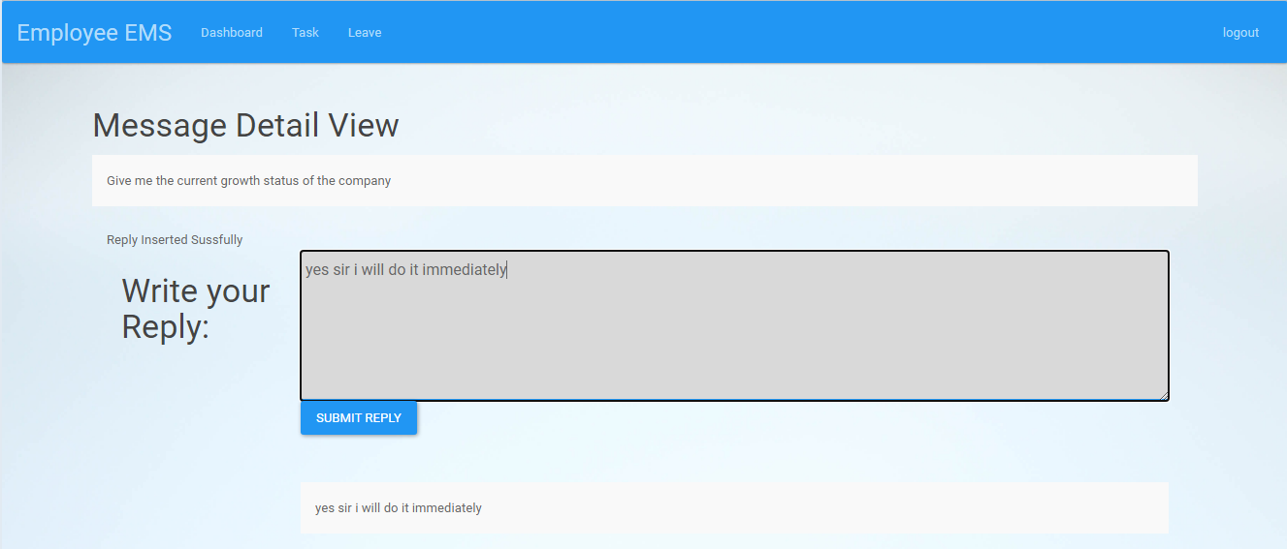

**APPLY LEAVE, CHECK STATUS OF LEAVE**

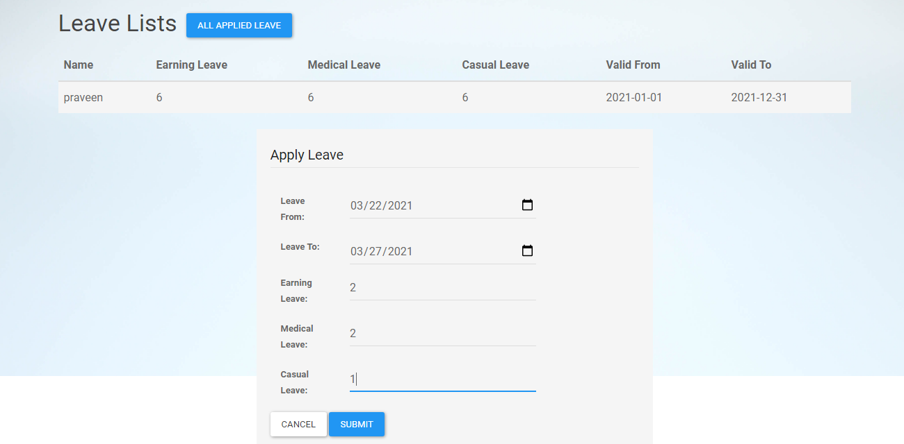

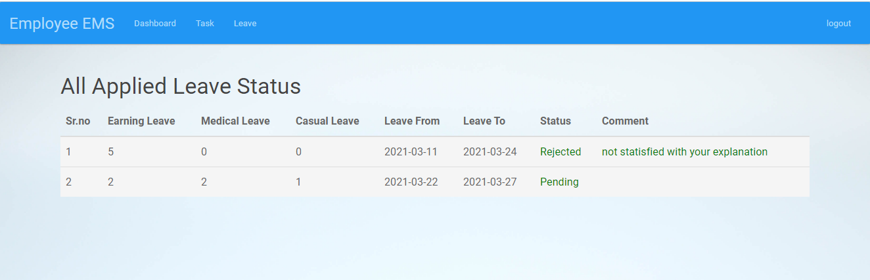

**CONCLUSION**

Overall, the system is useful for all the users to maintain information at various levels. It connects admin and employee and thus easy to maintain. Now admin can easily set the task or any notifications to the respective employees without having a person to send to employees and employees can apply for leave or reply with task allotted to them. It has been a great pleasure for me to work on this exciting and challenging project. This project proved good for us as it provided practical knowledge of not only programming in PHP, HTML, CSS and MySQL working of web based application, but also about all handling procedure related with Advance and new technology. It also provides knowledge about the latest technology used in developing web enabled application and client server technology that will be great demand in future. This will provide better opportunities and guidance in future in developing projects independently.

**FUTURE ENHANCEMENT**

* This project can be modified in future according to the need of the employees and administrator.
* Modules like attendance management and salary management can be added.
* The project can also be hosted in internet to reach many people and by doing some internal changes we make it as an Online Job Portal also.

**BIBILOGRAPHY**

1. https://www.phptpoint.com

2. http://www.javascriptkit.com

3. https://www.tutorialspoint.com/php/

4. https://www.w3schools.com